Ergonomics Equipment Guidelines: The equipment identified below is intended for the use of individuals receiving recommendations made by our Ergonomics Evaluators and utilizing vendors approved by GCCCD Purchasing and Contracts. If you have questions regarding alternative equipment, please contact Human Resources.
ITEM TYPE | SUPPLIER PART ID # | ITEM NAME | SUPPLIER / ORDERING | DESCRIPTION | IMAGE | Link
Keyboard Palm Rest | 498017 | Fellowes® PlushTouch™ Keyboard Wrist Rest, Black | OfficeMax | Includes Microban® antimicrobial protection. Built-in Microban antimicrobial protection provides an added level of cleanliness by inhibiting the uncontrolled growth of microbes.  Recommendation: Palm rest may be appropriate when awkward wrist angle is present without or discomfort is reported due to contact stress with the desk surface. | 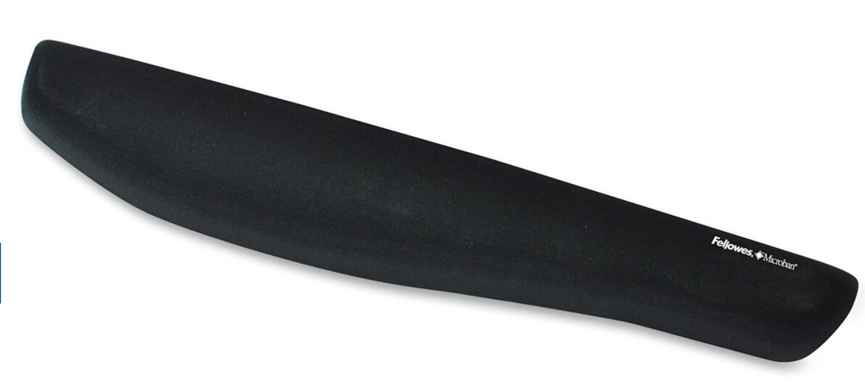 | https://www.officedepot.com/a/products/498017/Fellowes-PlushTouch-Keyboard-Wrist-Rest-Black/
Split Keyboard Palm Rest | 683873 | 3M™ Antimicrobial Gel Wrist Rest For Ergonomic Keyboards, 0.5"H x 4.3"W x 18.8"L, Black | OfficeMax | Thin profile for ergonomic "Split” keyboards. Leatherette covering. Anti- Non-skid base with Dual-Lock™ system attaches to keyboard.  Recommendation: Palm rest may be appropriate when awkward wrist angle is present without or discomfort is reported due to contact stress with the desk surface. Use this for the curved or split keyboards. | 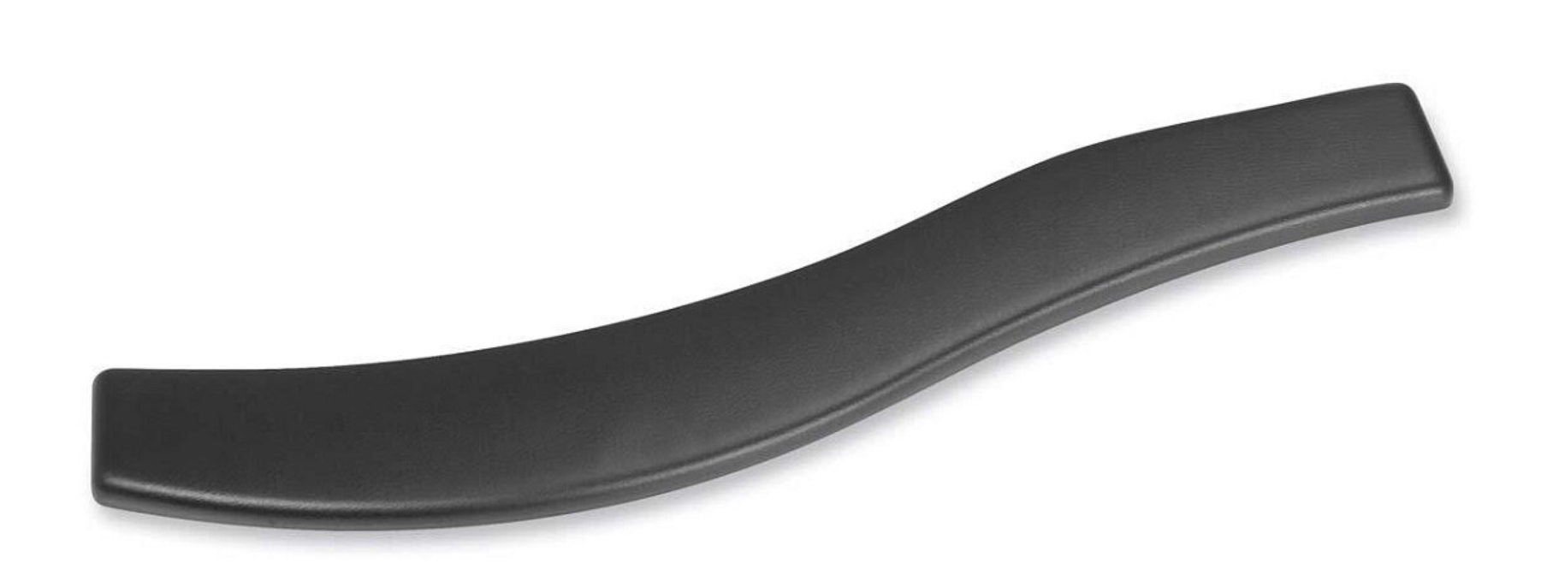 | https://www.officedepot.com/a/products/666785/3M-Antimicrobial-Gel-Wrist-Rest-For/
Mouse Palm Rest - integrated | 356247 | Fellowes® Gel Wrist Rest/Mouse Pad, Fabric, Black | OfficeMax | Durable jersey covering withstands daily wear and tear. Non-skid base holds wrist rest firmly in place.  Recommendation: Palm rest may be appropriate when awkward wrist angle is present without or discomfort is reported due to contact stress with the desk surface. | 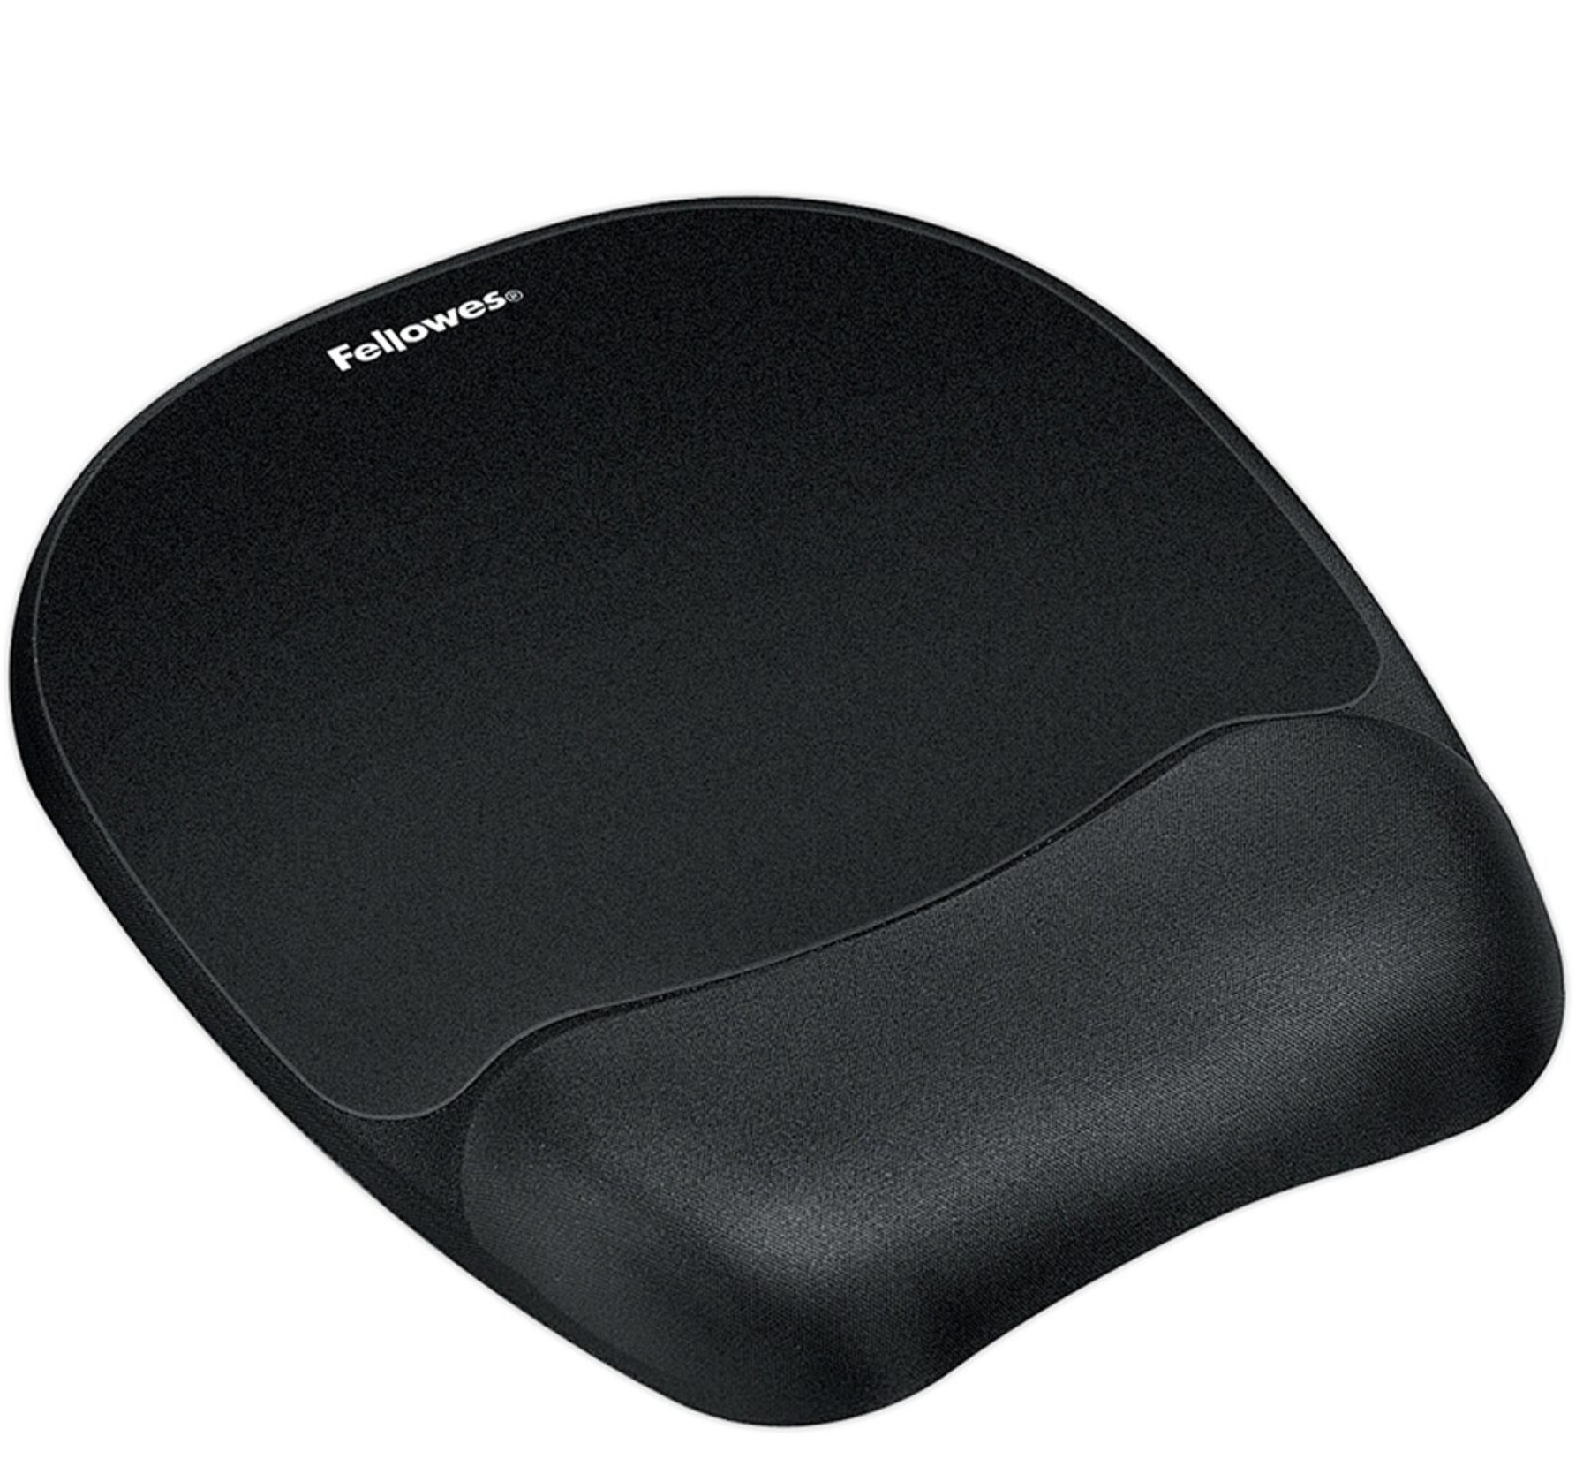 | https://www.officedepot.com/a/products/356247/Fellowes-Gel-Wrist-RestMouse-Pad-Fabric/
Mouse Palm Rest | 346185 | Allsop® Ergoprene Gel Mouse Wrist Rest, Black | OfficeMax | Memory foam supports your wrists and conforms to their contours. Helps relieve stress on pressure points. Retains body heat to improve blood circulation. Also helps prevent repetitive stress disorders. Non-skid rubber backing keep wrist rest in place  Recommendation: Palm rest may be appropriate when awkward wrist angle is present without or discomfort is reported due to contact stress with the desk surface. | 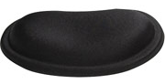 | https://www.officedepot.com/a/products/346185/Allsop-Ergoprene-Gel-Mouse-Wrist-Rest/
Footrest | 703058 | Mind Reader Comfy Adjustable-Height Foot Rest, 4.3"H x 18"W x 13.4"D, Black | OfficeMax | Accommodate your leg length by changing the height or angle of the foot platform. The tilting design lets you make adjustments while sitting  Recommendation: Footrests are an appropriate recommendation for many seated and standing workstations. In addition to providing a place to rest the feet if the employee cannot reach the floor in a seated position, footrests provide the opportunity for employees to change the foot posture which may increase low back comfort. Employees who habitually lean forward may benefit from a footrest which, when used, discourages forward bending through the hips. | 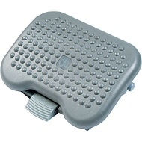 | https://www.officedepot.com/a/products/703058/Mind-Reader-Adjustable-Height-Footrest-4/
Footrest | 784218  18080 | Safco Adjustable Footrest, Black, 5"H x 18 1/2"W x 11 1/2"D  5” Articulating Footrest | OfficeMax  Ergostop | Steel frame/Vinyl covered MDF platform material. Easy glide design. Angle adjusts to 30º  Recommendation: Footrests are an appropriate recommendation for many seated and standing workstations. In addition to providing a place to rest the feet if the employee cannot reach the floor in a seated position, footrests provide the opportunity for employees to change the foot posture which may increase low back comfort. Employees who habitually lean forward may benefit from a footrest which, when used, discourages forward bending through the hips. | 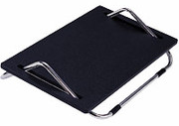 | https://www.officedepot.com/a/products/784218/Ergo-Comfort-Adjustable-Footrest-18-12w/  https://www.ergostop.com/product-page/3-articulating-foot-rest-18080
Monitor Riser | 113616 | 3M Adjustable Height Monitor Stand, 12 x 15 Platform, 80 lb. Capacity, Black/Silver | OfficeMax | Stacking columns raises monitor from 1" to 5.875" in increments of 1.625". Supports up to 80 lbs with 11" clearance underneath. Non-skid base.  Recommendation: Monitor riser allows non adjustable monitors to be incrementally raised. | 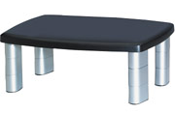 | https://www.officedepot.com/a/products/113616/3M-Adjustable-Height-Monitor-Stand/
Monitor Riser | 513104 | Fellowes® Office Suites™ Monitor Riser, Black/Silver, 4-1/5"H x 19-7/8"W x 14"D | OfficeMax | Height adjusts up to 2-½” (total range between 4” and 6-½”). Stows laptop underneath. Storage tray. Supports 21” monitors up to 80 lbs.  Recommendation: Monitor riser allows non adjustable monitors to be incrementally raised. | 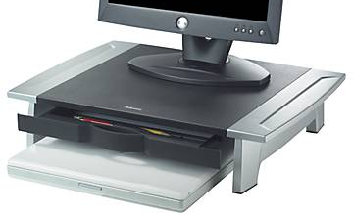 | https://www.officedepot.com/a/products/513104/Fellowes-Office-Suites-Small-Monitor-Riser/
Laptop / Monitor Riser | 113584 | 3M Vertical Notebook Riser, Black, 8 1/2"H x 8 1/2"W x 9 1/2"D | OfficeMax | Positions your notebook screen at an ergonomically correct height. Riser has 3 inches of vertical adjustability and is compatible with most docking stations. Non-skid base. Black and silver  Recommendation: Allows laptops to be used as a second screen height higher than if used open on the work surface. | 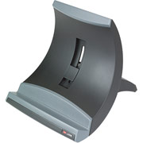 | https://www.officedepot.com/a/products/113584/3M-LX550-Adjustable-Notebook-Riser-Black/
Document Holder | 922981  80102 | 3M In-Line Document Holder – 14” (18” also available) | OfficeMax  Ergostop | Position in-line between monitor and keyboard. Weighted base allows ledge to dip below desk edge. Elastic line guide marks your place and keeps pages open. Back plate supports books, catalogs, and just about any size document .Angle and height adjustable, 300 sheet cap.**A 18” version is also available.  Recommendation: This document holder is sturdy enough to be used as an additional worksurface. This is appropriate when employees use the forward portion of the worksurface as for paperwork pushing the keyboard further back creating awkward arm postures. Functions who routinely enter data from paper sources may benefit from this equipment. | 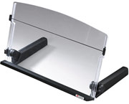 | https://www.officedepot.com/a/products/922981/3M-In-Line-Adjustable-Document-Holder/  https://www.ergostop.com/product-page/3m-in-line-14-document-holder-80102
Document Holder | 401624  80104 | 3M Desktop Document Holders. 18”, Black/Silver  3M Easel Document Holder | OfficeMax  Ergostop | Position in-line between monitor and keyboard.  Recommendation: This document holder is sturdy enough to be used as an additional worksurface. This is appropriate when employees use the forward portion of the worksurface as for paperwork pushing the keyboard further back creating awkward arm postures. Functions who routinely enter data from paper sources may benefit from this equipment. | 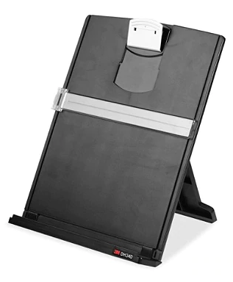 | https://www.officedepot.com/a/products/401624/3M-Desktop-Document-Holders-18-BlackSilver/  https://www.ergostop.com/product-page/3m-easel-document-holder-80104
Anti-Glare Screen | Dependent on Monitor Size | 3M LCD / CRT Monitor Anti-Glare Executive Glass Screen Filter | OfficeMax | 3M™ Anti-Glare Filter Screens work simply and beautifully on most of today’s monitors — including touchscreens — to help protect your screen and improve your view in indoor bright or challenging lighting conditions.  Recommendation: Use when glare from windows or light sources make screen viewing difficult or privacy is required. | 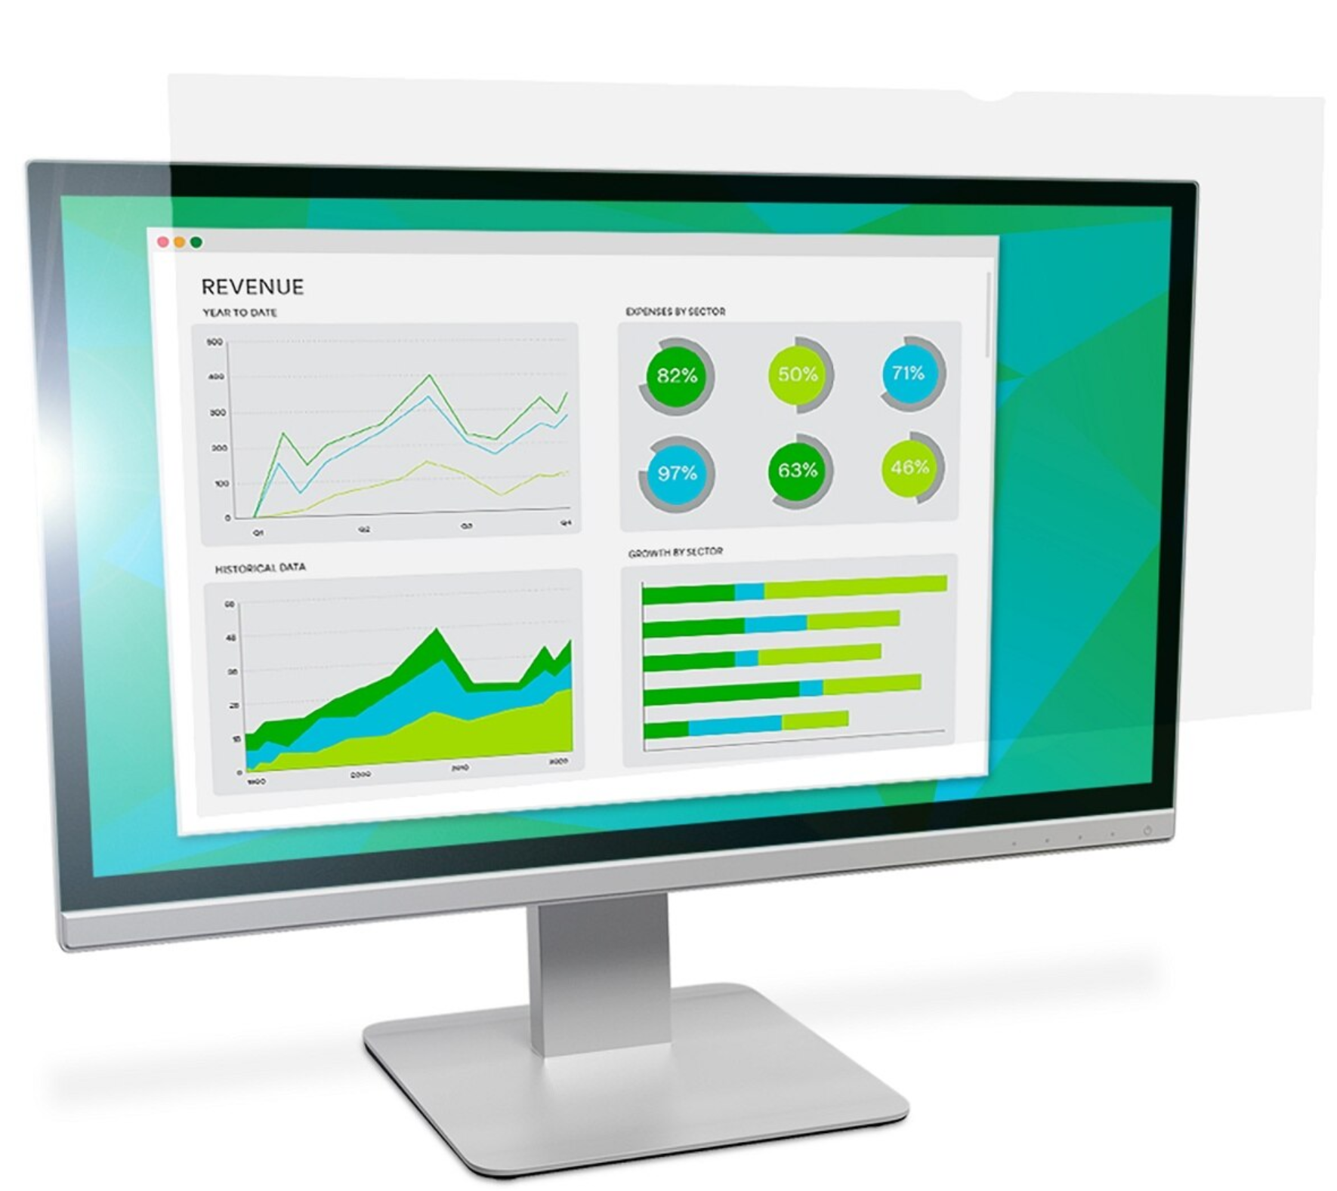 | Options Dependent on Size: https://www.officedepot.com/catalog/search.do?Nty=1&Ntx=mode+matchpartialmax&Ntk=all&Ntt=anti+glare+screen&N=5&cbxRefine=301407
Anti-Fatigue Mat | 808797 | Safco Anti-Fatigue Mat, Rectangular, 20” x 30”, Black | OfficeMax | Durable rubber, consist of a matrix of hollow cylinders that function like a spring when compressed. Stable footing, unique energizing responsiveness not found in other mats.  Recommendation: For use in primarily standing work areas. Appropriate anti-fatigue matting increases circulation through the legs and low back improving comfort in standing positions. | 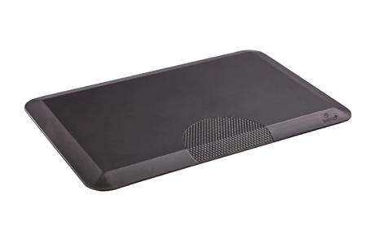 | https://www.officedepot.com/a/products/808797/Safco-Anti-Fatigue-Mat-Rectangular-20/
Anti-Fatigue Mat | 93004 | Sit Stand Smart Mat | Ergostrop | Durable rubber, consist of a matrix of hollow cylinders that function like a spring when compressed. Stable footing, unique energizing responsiveness not found in other mats.  Recommendation: For use in primarily standing work areas. Appropriate anti-fatigue matting increases circulation through the legs and low back improving comfort in standing positions. |  | https://www.ergostop.com/product-page/sit-stand-smart-mat
Mouse | 7789173 | Logitech Performance Mouse MX Master 3 | OfficeMax | Laser tracking, fast scrolling.  Recommendation: May be appropriate if a traditional mouse creates awkward hand postures. Right handed shape only. | 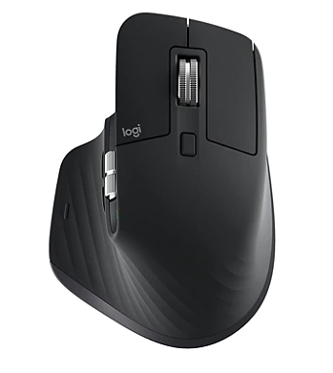 | https://www.officedepot.com/a/products/7789173/Logitech-MX-Master-3-Advanced-Wireless/
Mouse | 38210 | Contour Mouse (formerly Perfit Mouse) | Ergostop | Four right-handed (S-XL) sizes and two left-handed (M-L) sizes.  Recommendation: May be appropriate if a traditional mouse creates awkward hand postures. | 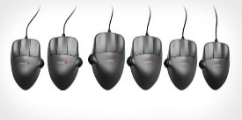 | https://www.ergostop.com/product-page/contour-mouse-38210
Mouse/  Input device | 38035 | Contour Design RollerMouse Pro 3 | Ergostop | It sits in below your keyboard, eliminating the need to reach for the mouse, which can stress your neck, shoulders, elbows, and wrist.  Recommendation: If employees are unable to comfortably use a side placed mouse, the roller mouse may be appropriate as it reduces abduction and external rotation. | 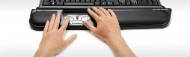 | https://www.ergostop.com/product-page/rollermouse-pro3
Mouse | 354804 | Evoluent VM4L Vertical Mouse, Left-handed, Black | Officemax | Vertical mouse. USB. The patented shape supports your hand in an upright neutral posture. May not be appropriate for high repetition of switching between keyboard and mouse use.  Recommendation: This mouse may be appropriate for employees who use the mouse for 90% of their computer work. It may not be appropriate for general computer usage as it can create the risk of exposure to repetitive forearm rotation. | 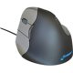 | https://www.officedepot.com/a/products/354804/Evoluent-VerticalMouse-Left-Hand-Optical-Mouse/
Mouse | 555106  38075 | Evoluent VM4R Vertical Mouse, Right-handed, Black  Evoluent Vertical Mouse Wireless | Officemax  Ergostop | Vertical mouse Optical sensor. Interface: USB. The patented shape supports your hand in an upright neutral posture. May not be appropriate for high repetition of switching between keyboard and mouse use.  Recommendation: This mouse may be appropriate for employees who use the mouse for 90% of their computer work. It may not be appropriate for general computer usage as it can create the risk of exposure to repetitive forearm rotation. | 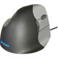 | https://www.officedepot.com/a/products/555106/Evoluent-Vertical-Mouse-4-For-Right/  https://www.ergostop.com/product-page/evoluent-verticle-mouse-wireless-38075
Mouse | 782794 | SHI Kensington Orbit Optical Trackball – 2 Button – USB | Officemax | Allows precise fingertip control. Hand-hugging design and gentle upward slope provide wrist support to ease fatigue. Symmetrical shape for both left and right handed users.  Recommendation: Generally trackballs are more suited to precise mouse work than general email/data entry. The trackball may allow for reduced abduction through the arm. Note that use with double or extra large screens may require additional setting adjustment. | 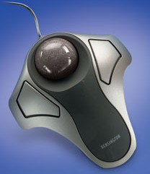 | https://www.officedepot.com/a/products/782794/Kensington-Orbit-Optical-Trackball-Metallic-SilverBlack/
Mouse | 329234 | Kensington Expert Mouse® Optical Trackball, Black/Silver | Officemax | Diamond eye optical tracking for superior accuracy. USB and PS/2. Award-winning Scroll Ring for precise fingertip scrolling. Exceptional comfort. Large ball for maximum precision and control. Detachable wrist rest cradles hand.  Recommendation: Generally trackballs are more suited to precise mouse work than general email/data entry. The trackball may allow for reduced abduction through the arm. Note that use with double or extra large screens may require additional setting adjustment. | 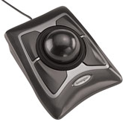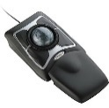 | https://www.officedepot.com/a/products/329234/Kensington-Expert-Wireless-Optical-Mouse-TrackBall/
Mouse | 851265 | Logitech Marble® Mouse | OfficeMax | Good for Larger Hands. Optical scrolling. Large trackball improves control while reducing hand and wrist motion. Optical technology. 4 customizable buttons. Fast cruise-control scrolling. Convenient drag-lock technology. Comfortable, curved design.  Recommendation: Generally trackballs are more suited to precise mouse work than general email/data entry. The trackball may allow for reduced abduction through the arm. Note that use with double or extra large screens may require additional setting adjustment. | 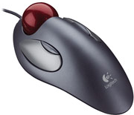 | https://www.officedepot.com/a/products/851265/Logitech-Marble-Mouse-Silver/
Keyboard / Accessory | 286805  39223 | Microsoft  Microsoft Sculpt Ergonomic Keyboard, Black  Microsoft Sculpt Ergonomic Keyboard for Business | Officemax  Ergostop | USB interface. Customizable hot keys. Microsoft's most comfortable keyboard with breakthrough ergonomic design. Ergonomic "split design" with curved keys and cushioned wrist pad.  Recommendation: A wider or ‘split’ keyboard may be appropriate for individuals whose shoulder/chest breadth creates awkward hand/wrist postures when using a traditional keyboard. This may not be appropriate for very petite users. | 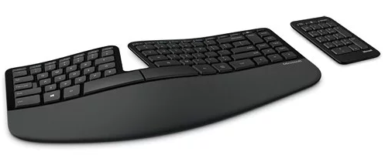 | https://www.officedepot.com/a/products/286805/Microsoft-Sculpt-Ergonomic-Keyboard-Black/  https://www.ergostop.com/product-page/microsoft-sculpt-ergonomic-keyboard-for-business
Keyboard / Accessory | 39362 | CEI Keyboard Left Handed Usb A-4 Tech Wired Ergoguys | Ergostop | CEI A-4 Tech Erg guys, Black, Ps/2.  Recommendation: Left side 10 key available for users who are not able/comfortable using the right side 10 key. | 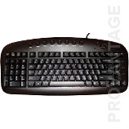 | https://www.ergostop.com/product-page/left-handed-relax-ergo-keyboard-39362
Keyboard / Accessory | 39225 | Mini Keyboard w/ retractable Number Pad | Ergostop | Narrow keyboard. Wireless. AAA battery operation with USB connection. Retractable number pad to reduce levels of reaching.  Recommendation: May be appropriate for petite users or employees who are not able to comfortably abduct or externally rotate the arm for mouse use (the narrow keyboard brings the mouse placement closer to the user than a traditional keyboard). | 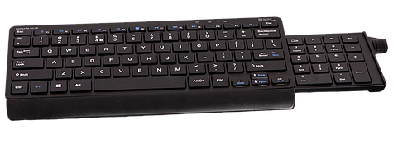 | https://www.ergostop.com/product-page/mini-arch-keyboard-with-number-slide-39225
Keyboard / Accessory | 563236  39282 | Kinesis Low Force Numeric Ergonomic Keypad for PC,Black  Kinesis Freestyle2 Low Force Numeric Keypad | Officemax  Ergostop | Integrated 2 port USB 2.0 hub. Same low-force, tactile membrane key switch as the Freestyle2 keyboard. Low profile design of the Freestyle2 design. Embedded hot keys “Cut” & “Paste”  Recommendation: Allows additional adjustability of placement for users with intensive 10 key use. | 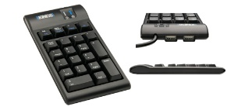 | https://www.officedepot.com/a/products/563236/Kinesis-Low-Force-Numeric-Ergonomic-Keypad/  https://www.ergostop.com/product-page/freestyle2-kinesis-low-force-numeric-pad-39282
Keyboard / Accessory | 347069  39280 | Kinesis Freestyle 2 Keyboard for PC with Up to 20” Separation  Kinesis Freestyle2 Keyboard for PC | Officemax  Ergostop | Up to 9” separation between left and right halves of keyboard with Pivot Tether™. Wired, USB. Good for wider placements. Low-force keys. Embedded 10-key. Hot keys for Cut, Copy, Paste.  Recommendation: A wider or ‘split’ keyboard may be appropriate for individuals whose shoulder/chest breadth creates awkward hand/wrist postures when using a traditional keyboard. This may not be appropriate for very petite users. | 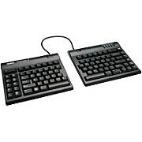 | https://www.officedepot.com/a/products/989638/Kinesis-Freestyle2-Ergonomic-Keyboard-For-PC/  https://www.ergostop.com/product-page/freestyle-2-keyboard-39280
Telephone Accessory | 592775 | Plantronics M22 Universal Amplifier  Required when ordering headsets below | OfficeMax | Traditional and VoIP phones. Clearline audio technology. Echo management for clear calls. Protection from loud, Background noise. Volume, headset/handset and mute controls. One-button selection of headset or handset. | 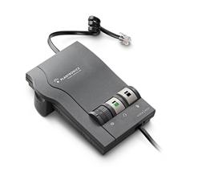 | https://www.officedepot.com/a/products/592775/Plantronics-Vista-M22-Amplifier/
Telephone Accessory | 697815 | Plantronics HW261N SupraPlus  Adaptor M22 required for use | Officemax | Superior audio performance, more natural sound with wideband telephones. The highest level of performance for wideband VoIP communications. Binaural (dual-ear), noise canceling microphone.  Recommendation: Eliminates awkward postures associates with phone cradling while using the mouse/keyboard. The employee should specify headset/earbud preference. | 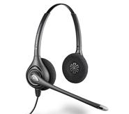 | https://www.officedepot.com/a/products/697815/Plantronics-SupraPlus-HW261N-Binaural-Wideband-Headset/
Telephone Accessory | 967292 | Plantronics EncorePro Monaural Over-The-Head Headset, HW510, Black | Officemax | Plush ear cushions. Nylon composite materials for featherweight comfort. Reinforced lightweight headband. Superior noise-canceling microphone on sliding, low-sitting boom/microphone not visible to wearer.  Recommendation: Eliminates awkward postures associates with phone cradling while using the mouse/keyboard. | 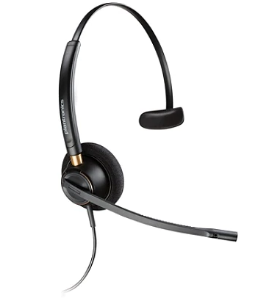 | https://www.officedepot.com/a/products/967292/Plantronics-EncorePro-Monaural-Over-The-Head/
Telephone Accessory | 985457 | Plantronics Voyager 5200 Bluetooth Mobile Over the Ear Headset, Black | OfficeMax | Swiveling receiver, voice tube, microphone. Sculpted ear loop fits behind the ear. Quick Disconnect - walk away from the phone while still wearing headset.  Recommendation: Eliminates awkward postures associates with phone cradling while using the mouse/keyboard. The employee should specify headset/earbud preference. | 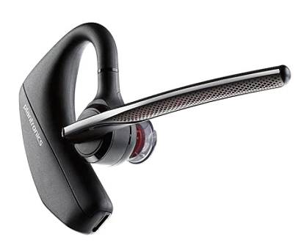 | https://www.officedepot.com/a/products/985457/Plantronics-Voyager-5200-Bluetooth-Mobile-Over/
Keyboard Tray | 704400 | 3M 70% Recycled Adjustable Keyboard Tray, Black/Charcoal, AKT60LE | Officemax | Standard Track length 22 5/8”. Knobless height adjustment of 6.25”. Soft touch adjusts tilt of tray up to (-) 15°. Pivots side to side 360 degrees. Surface is sized for keyboard and mouse. Comes with wrist rest (length of platform).  Recommendation: Provides additional adjustability to set height desks. | 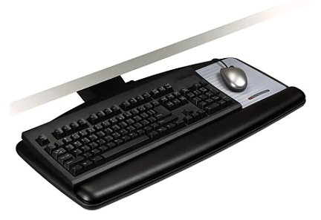 | https://www.officedepot.com/a/products/704400/3M-70percent-Recycled-Adjustable-Keyboard-Tray/
Keyboard Tray | 558501 | Fellowes Standard Articulating Keyboard Manager | Officemax | Standard Track Length 22”. Knobless height adjustment of 6.25”. Soft touch knob adjusts tilt of tray up to (-) 15º. Pivots side to side. Surface is sized for keyboard. Comes with wrist rest. Mouse tray slides out from underneath.  Recommendation: Provides additional adjustability to set height desks. | 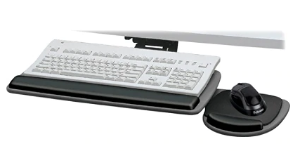 | https://www.officedepot.com/a/products/558501/Fellowes-Standard-Articulating-Keyboard-Manager/
Corner Sleeves | 876330 | 3M Corner Maker | Officemax | Creates 17 5/8” wide VDT corner, 9” from work surface corner. ¼” screw holes on underside for optional attachment to work surface. Dimensions: 26 ¾" W x 9 1/8" D x 1 ¼" H **Available in thicknesses of 1 ¾ “ and 2 ½” as well. Must specify.  Recommendation: May assist with improving awkward postures associated with leaning and reaching in corner workstations. | 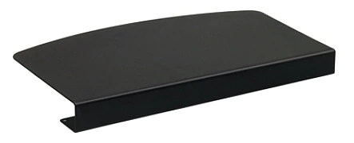 | https://www.officedepot.com/a/products/876330/3M-Corner-Maker/
Monitor Arm | 137623 | Ergotron LX Desk Mount LCD Arm | Officemax | Available in Platinum or Charcoal. Supports monitors of 5-20 lbs. Integrated cable management.  Vertical Height Adjustment: 11.5”  Recommendation: Provides adjustability for monitor placement. | 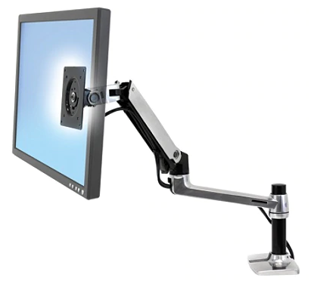 | https://www.officedepot.com/a/products/137623/Ergotron-LX-Desk-Mount-LCD-Arm/
Monitor Arm | 39242 | M2 Monitor Arm | Ergostop | Arm links are only 1.1" thick. Fingertip adjustment is accomplished via a spring instead of a gas cylinder which makes this arm extremely durable and long lasting, as well as lighter than many LCD arms. The M2 LCD arm is also Apple compatible. Choose either clamp or bolt through. Supports up to 24” wide and 20#.  Recommendation: Provides adjustability for monitor placement. | 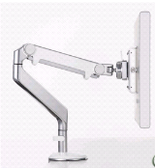 | https://www.ergostop.com/product-page/m2-monitor-arm
Chair | PT69 | Multi-Function Task Chair | Ergostop | Dimensions: Back: 17”W x 22”H, Seat: 19”W x 16.5”-19”D  Weight Capacity: 300 lbs.  Consult ergonomist for product configuration if using officerelief website. | 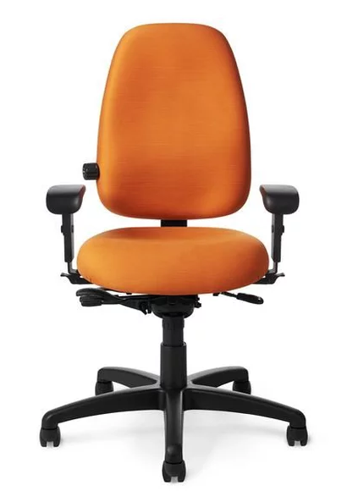 | https://www.ergostop.com/product-page/multi-function-task-chair  Another vendor option: https://store.officerelief.com/prodcfg/Products/Chairs/Petite-Chairs/PT69/OM-PT69-Paramount-Chair-Small-Petite-Build
Chair | PT74 | OM PT74 Paramount Chair, Medium Build | Officerelief | Dimensions: Back: 17”W x 18”H, Seat: 20”W x 17”-19.5”D  Weight Capacity: 300 lbs | 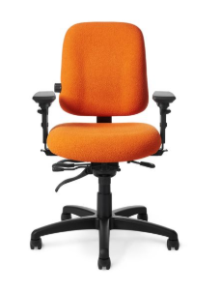 | https://store.officerelief.com/prodcfg/Products/Chairs/Task-Chairs/PT74/OM-PT74-Paramount-Chair-Medium-Build
Chair | PTYM | OM PTYM Paramount Chair, Large/Extra-Tall Build | Officerelief | Dimensions: Back: 19.5”W x 22”H, Seat 21”W x 24.6”D  Weight Capacity: 300 lbs | 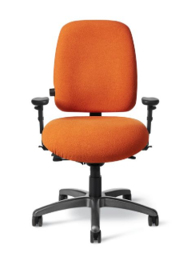 | https://store.officerelief.com/prodcfg/Products/Chairs/Big-Tall-Chairs/PTYM/OM-PTYM-Paramount-Chair-Large-Extra-Tall-Build
Chair | 11951 | Ultra Mesh Mid-Back Intensive Task Chair | Ergostop | Option for mesh back for chair option with 5 paddle adjustments for chair. | 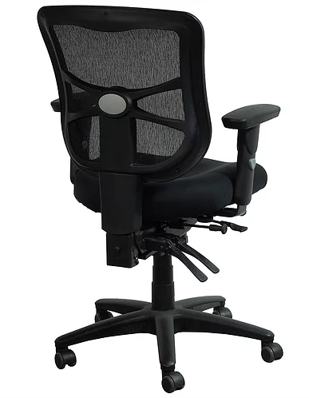 | https://www.ergostop.com/product-page/ultra-mesh-mid-back-intensive-task-chair

